

AUGUSTA SIGNATURE ~ $529,990
City of Oconomowoc, Waukesha County
*** Prairie Creek Ridge ~ Addition #3 Subdivision ***
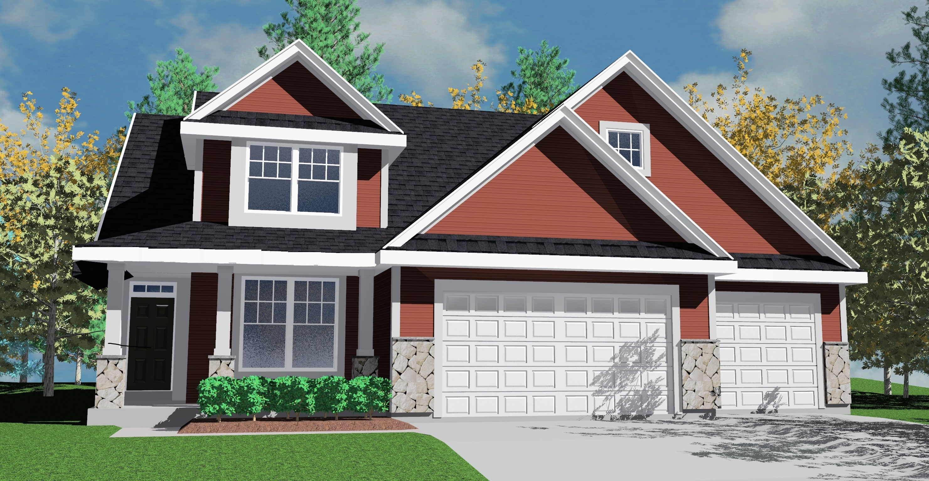
Picture is a rendering only: drawing is conceptual only ~ it varies from actual home plan & exterior selections

LOCATION: Lot 190; 1491 Whalen Drive JOB #: 8998
---- ---------------------------------------------------------------------------------------------------------------------------------------------------------------
Lot Area: Approx. 14,642 sq. ft. Living Area: Approx. 2,660 sq. ft. Tentative Completion: (check w/salesperson)

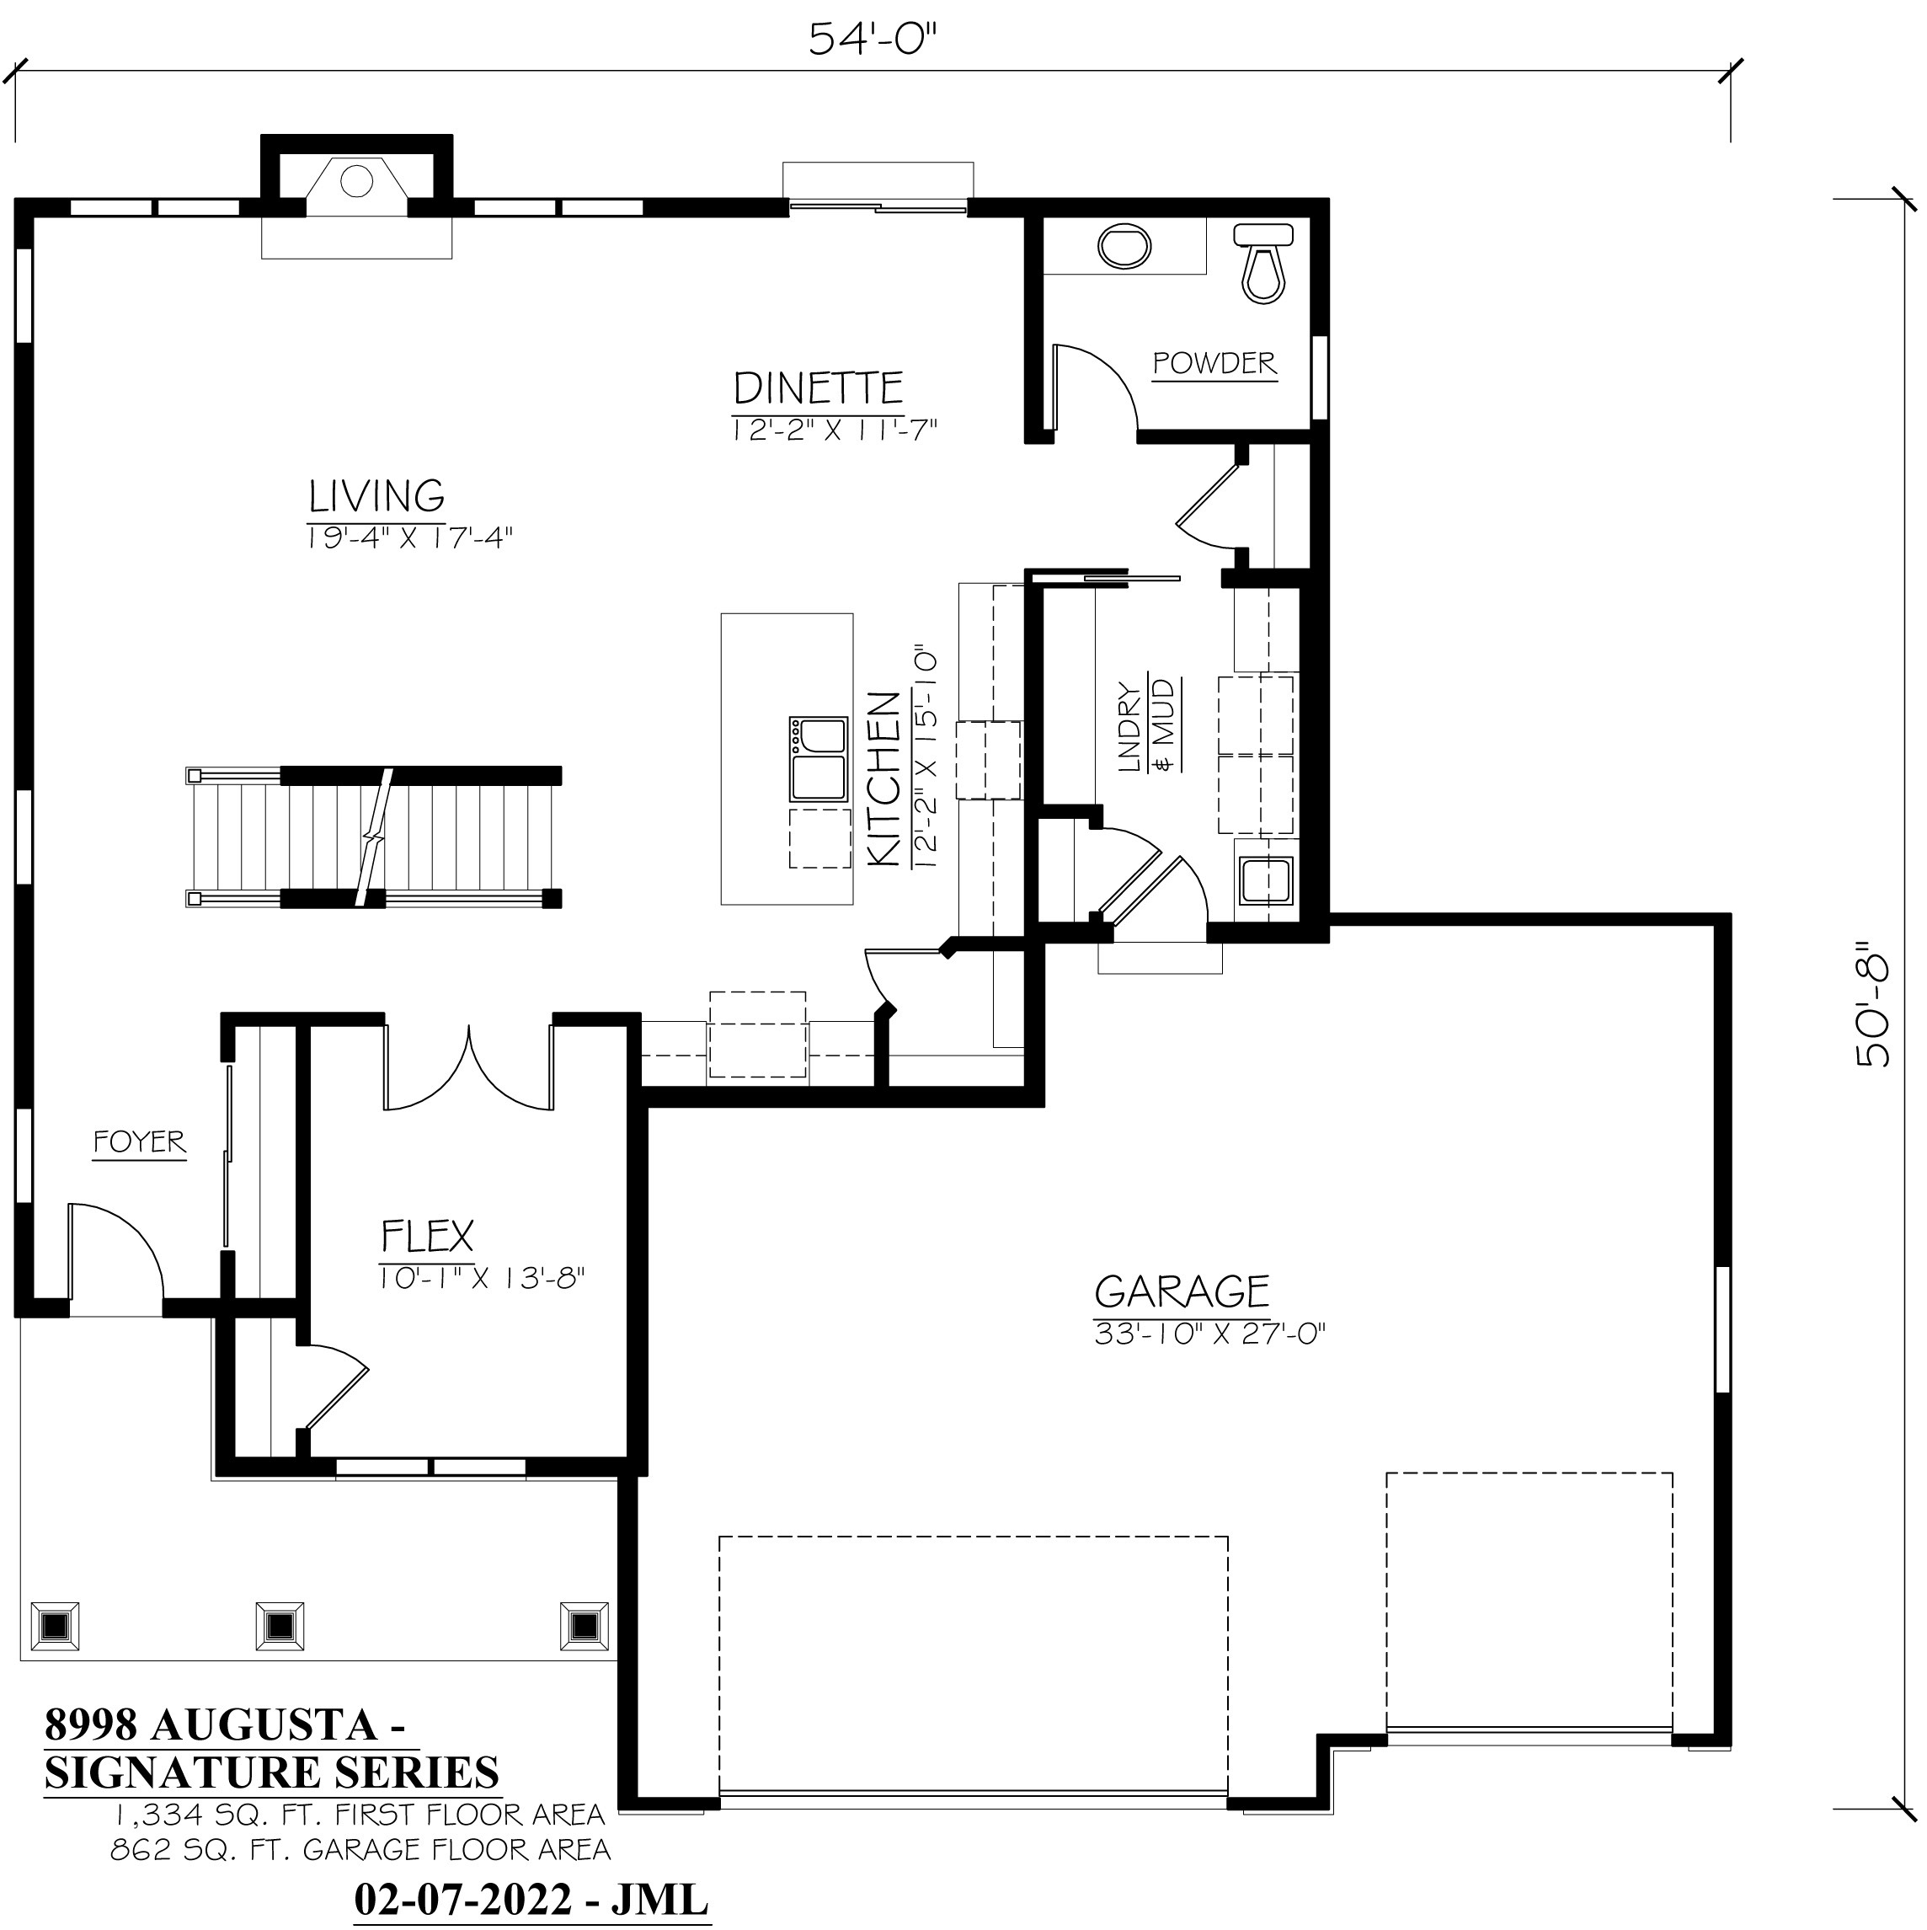
Augusta Signature Features:
4 Bedrooms / 2.5 Bathrooms / Flex Room / Spacious 2-Story / Signature Series Design
8’ Poured concrete foundation wall / (1) egress slider window per plan
Basement drain/vent rough-in for future full bathroom
Bathroom vanities & mirrors / prefab granite or equivalent vanity tops
Ceramic tiled shower walls w/shower pan in master bathroom / one shower head
Double sinks in master & family bathrooms / shower over tub in family bathroom
Walk-in closets in all bedrooms / satin nickel closet shelving
Knockdown drywall w/rounded corners / walls painted one-coat neutral color
9’ 1st floor ceilings / tray ceiling in master bedroom / paneled doors / lever-style door handles
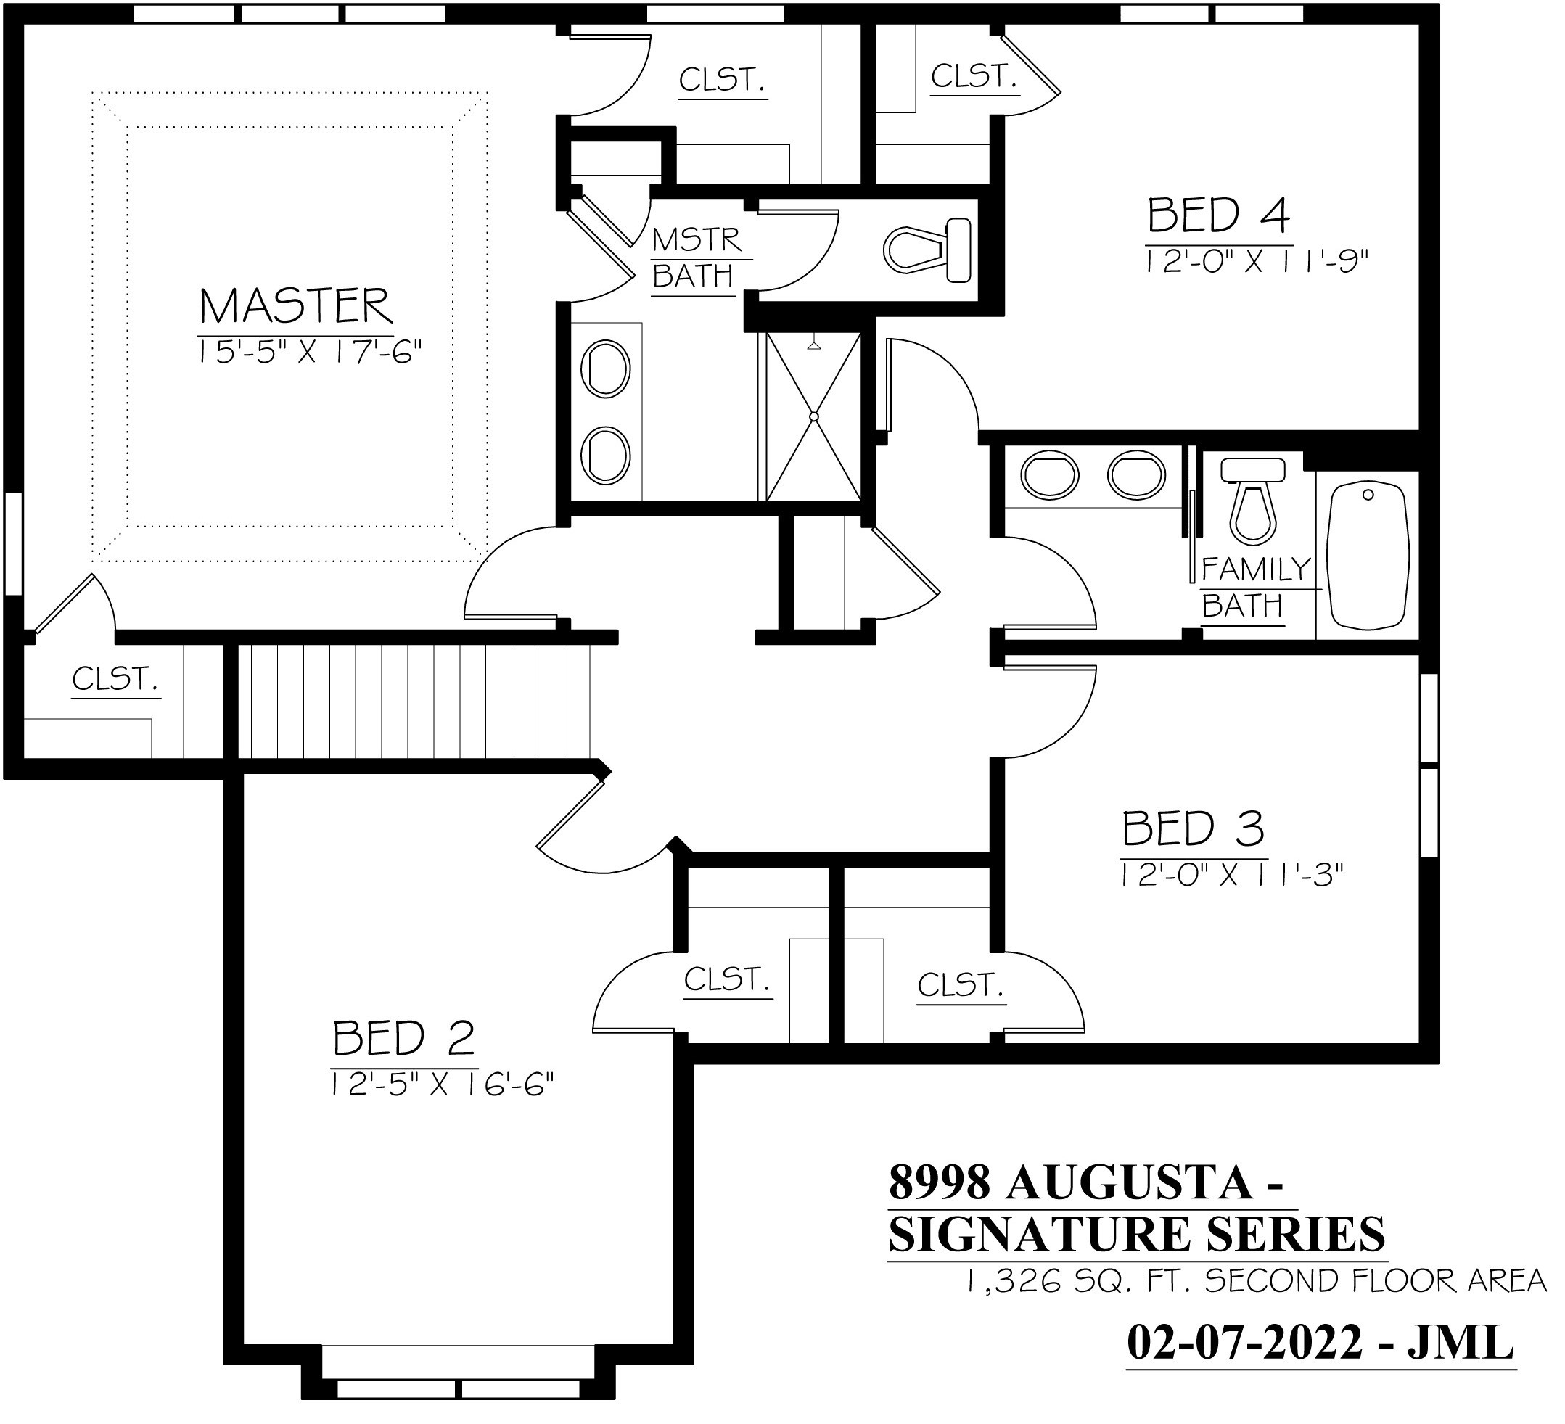
Signature series kitchen cabinets ~ staggered w/cabinet crown molding per plan design
Granite or equivalent kitchen countertops / kitchen island w/sink / pantry closet
Built-in SS dishwasher / SS microwave oven / garbage disposal
Direct-vent gas projected fireplace ~ facing & mantel as designed on plan
Main floor laundry/mudroom w/drywall lockers, closet, cabinets & sink per plan design
Newel posts / iron balusters / carpet / laminate / ceramic tile flooring package
Gas connection to range area & dryer area
High-efficiency furnace / 50-gallon water heater / central air (low returns)
200-amp electrical service / bedroom ceiling lights / interior/exterior recessed lighting per plan
Partial stone facade / covered front porch w/prairie-style box posts as designed on builder’s plan
Kaerek Homes, Inc.
11600 W. LINCOLN AVE.
WEST ALLIS, WI 53227-1018
PHONE: 414-321-5300
FAX: 414-321-8622
www.kaerekhomes.com


6-Panel entry door w/transom window / keypad deadbolt
Maintenance-free vinyl windows / grids, maintenance-free trim & corner boards on all elevations
Maintenance-free vinyl siding / gable roof / dimensional roof shingles
Aluminum gutters, downspouts, soffit & fascia
3-Car garage / paneled overhead doors / 6-pane window panels / door openers / remotes / keypad
2” x 6” exterior house walls; 7/16” OSB sheathing
SPECIAL PRE-COMPLETION PRICING AS STATED ABOVE
- Sales Terms: $15,000 Deposit at Contract Date
- Financing: Bank Five Nine; Charlie Johnson (262) 853-6256
- Closing Within 10 days of Occupancy Permit Date
2/10/22 Price subject to change without notice ~
Builder reserves the right to modify above selections & features during construction process

